IOT based smart system for garbage detection and segregation

Dr.M.V.Rajesh

*Professor,Department of IT*

*Aditya Engineering College*

Surampalem, India

rajesh.masina@aec.edu.in

Chitturi Devi Priyanka  
*Department of IT,*

*Aditya Engineering College*

Surampalem, India  
priyankachitturi0416@gmail.com

A.Lakshmanarao  
Department of IT  
*Aditya Engineering College* Surampalem, India  
laxman1216@gmail.com

Jai Sai Akshay Rongala   
Department of IT  
*Aditya Engineering College* Surampalem, India  
jaisaiakshayrongala@gmail.com

*Abstract*— **Rapid growths in the amount and varieties of conventional and toxic waste as a consequence of continuing economic expansion, growing urbanization, and economic growth have resulted in a growing concern to assure the effective and environmentally friendly handling of garbage. This issue expected to get worse in the future years. An automatic garbage segregation helps prevent this predicament and also makes recycling easier, thus it becomes an essential component of modern waste management. When garbage is broken down into its many components, its importance and economic value may be appreciated. This paper proposes IOT-based automated dustbin. The proposed dustbin robot is equipped with sensors to detect when it is closed to a bin that needs to be emptied. An ultrasonic sensor detects whether the trash can is full. Here Ultrasonic Sensor is mounted at the top of Trash Can to detect rubbish distance from the top and establish a threshold value according to trash can size. If the distance is less than this threshold value, the trash can is filled and we will post "Basket is Full" on the homepage. If it is greater than this threshold value, we will publish "Basket is Empty". The model has a 5 cm threshold. The dustbin will self-navigate to the dumping place and return to the source once reaching the threshold. The proposed system also proposes a garage segregation module which helps to separate garbage.**

Keywords—Garbage, IOT, Smart Dustbin, Ultrasonic Sensors.

# Introduction

In the past few years, disposing of garbage has emerged as a major source of worry all across the globe. The massive quantity of garbage which is produced each day is got rid of by adheres to that are harmful to the surrounding natural ecosystem. The trash is often disposed of at landfill sites by unprepared and unregulated open dumping, which is the most prevalent disposal method [1]. This practice is harmful to the wellness of both humans and the natural plant and animals that live around them. The result is a rise in the level of airborne pollutants, which has an impact on the ecosystem. When there is a larger concentration of CO2 and methane in the atmosphere, it has an effect on the ozone layer, which in turn causes global warming. The effects of global warming on the natural world include things like an increase in temperatures, an increase in the level of the oceans, and the disappearance of the monsoon. It might be difficult to sort trash into biodegradable and nonbiodegradable groups. These wastes are traditionally separated by hand, a laborious procedure that takes a lot of time. The Internet of Things (IoT) makes it simple to determine what sort of garbage is being thrown out and how much of it there is. Additionally, IoT allows for the monitoring of carbon dioxide and methane emissions. Many environmental monitoring applications, from greenhouse gas to pollution to plant-growth trackers, employ the Internet of Things. IoT-based garbage monitoring systems can help municipalities and waste management companies optimize waste collection routes, reduce collection costs, and improve operational efficiency. IoT devices can provide real-time data on garbage levels, allowing waste management teams to know when a container is full and needs to be emptied. This reduces the risk of overflowing trash and potential health hazards. loT-based garbage monitoring can help reduce the risk of pest infestations, unpleasant odors, and other health hazards associated with overflowing garbage. Efficient waste management through IoT-based monitoring can reduce the amount of waste that ends up in landfills, helping to minimize environmental impact. With optimized waste collection routes, IoT-based garbage monitoring systems can help reduce labor, fuel, and equipment costs associated with traditional garbage collection methods. There are several IOT devices used in this work. The goal of this effort is to provide a low-cost, intelligent garbage can for specific, localized applications like parks, campuses, cafes, hospitals, etc., so that urban areas may remain clean and attractive. The Internet of Things (IoT) has emerged as a transformative technology with the potential to revolutionize various industries, including waste management. IoT-based smart systems integrate sensors, actuators, and communication technologies to enable real-time monitoring and data exchange between physical objects and the digital world. In the context of waste management, smart sensors are deployed in garbage bins to monitor fill levels, temperature, and other relevant parameters.

The objective of this intelligent waste management approach is twofold: Garbage Detection and waste segregation. In garbage collection, IoT-enabled smart systems facilitate real-time garbage detection by continuously monitoring the fill levels of waste bins. When a garbage bin reaches a certain threshold level, the system triggers an alert to waste management authorities, indicating that it requires emptying. This ensures timely waste collection and prevents overflowing bins, which can attract pests and lead to unsightly surroundings. In waste segregation, another crucial aspect of smart waste management is waste segregation. Traditional waste management often relies on manual sorting, which can be time-consuming and error-prone. With IoT-based smart systems, the integration of sensors and image processing technologies enables automated waste segregation. The system can classify waste items into recyclable and non-recyclable categories, promoting more effective recycling practices and reducing the burden on landfills.

The details of devices used in this work for garbage collection and segregation are given below.

**Arduino Uno**

The UNO is best for beginners. The UNO is the most popular and documented Arduino board.

**IR Sensors**

Electrical infrared sensors detect and measure infrared light generated by an item or its surroundings. The IR sensor uses infrared radiation to recognize its surroundings. These sensors measure heat and motion. Many electronics depend on the IR sensor circuit.

**Indictive Proximity Sensors**

Metal targets approaching an inductive proximity sensor can be detected without physical touch. Inductive proximity sensors are loosely divided into three categories based on their operating principle: high-frequency oscillation, magnetic, and capacitance.

**Moisture Sensors**

The soil moisture sensor measures soil water volumetrically. As the straight gravimetric dimension of soil moisture necessitates removing, drying, and sample weighing. Using soil principles like dielectric constant, electrical resistance, neutron interaction, and moisture replacement, these sensors assess volumetric water content indirectly.

**Servo Motors**

Servo motors revolve precisely. Servo motors rotate precisely because a control circuit gives input on the motor shaft's position. Servo motors rotate objects at particular angles or distances. A basic motor drives a servo mechanism. DC servo motors are DC-powered, whereas AC-powered ones are AC-powered.

**Stepper Motors**

A brushless DC electric stepper motor splits a whole revolution into equal steps. If the motor is properly designed for torque and speed, an open-loop controller can direct the motor to move and hold at one of these stages without a position sensor.

**Buzzers**

Mechanical, electromechanical, or piezoelectric buzzers or beepers are auditory signalling devices. Buzzers and beepers are used in alarms, clocks, trains, and user input confirmation.

**Controller**

A computer controller oversees data flow between two entities. Cards, microchips, or hardware devices can control peripheral devices in computers.

**Voltage Regulator**

A voltage regulator maintains a stable output voltage regardless of input voltage or load circumstances.

# literature survey

Sayali Sonde[1] et al. proposed a intelligent dustbin using Arduino. The authors developed a smart dustbin using various sensors for segregating garbage. A. Tripathi [2] et al. proposed a proposed a cloud oriented garbage system for metro stations using Internet of Things technology and achieved good result with their model. The authors proved that the RFID-based Smart Dustbin System is indicative of the sensor-laden trash cans of the future. In this paradigm, safety is the number one priority. During the 2008 series of explosions in Delhi, several of the explosives went off in trash cans. Trash cans were missing from every Delhi Metro station after the bombings. This is because bombs may be conveniently hidden in trash cans. at this research, we provide a workable option for garbage cans at subway stations. This smart garbage can prototype was built using radio frequency identification (RFID) tags, an RFID reader. The technology employs a cloud-based monitoring system to keep tabs on garbage. Using a cloud-based solution eliminates the need to routinely empty trash cans. For environmental reasons and to make the metro as carbon neutral as possible, they utilized a modest solar panel as our primary power source.

There is a growing need for reliable and adaptable security solutions in the commercial world. Radio-frequency identification (RFID) is an efficient and dependable method of product labelling. This work presents an innovative approach to garbage separation using IoT and robotics. The system employs sensors to identify different types of waste, and a robotic arm is utilized for sorting them into appropriate bins. The study showcases the efficiency and accuracy of the smart waste sorting system, reducing the need for manual labor in waste segregation.Barcodes were originally favored over RFID due to their cheaper price, but today RFID has surpassed barcodes in both availability and ease of use[3]. Nabaneeta Banerjee [4] develop a smart dustbin for garbage segregation. To keep garbage from blowing about, the models dustbin lid may be set to remain closed until it's time to empty the contents. It presents the successful implementation of IoT-enabled smart bins for waste management in a city. The authors describe the architecture of the system, including sensors for waste level detection, GPS tracking, and connectivity protocols. The study showcases how real-time data from smart bins can be utilized to optimize waste collection routes and enhance waste segregation practices.

IoT rules for transferring dustbin status that can trigger email to notify responsible party that system is full of garbage and needs to be replaced is central to this project's concept for a more efficient approach to waste management. The Espresso chip, based on the ESP8266 node MCU platform, has been chosen. The ultrasonic sensor will display the degree to which the trash can is full, while the proximity sensors will identify any obstacles in its path and prevent a crash. LCD interface has been completed to display the current state of the trash can[5]. In [6], the authors created and installed intelligent waste receptacles on campus and educated students, staff, and faculty on proper waste management practises. Mini-smart dustbins and super-smart dustbins are two examples of the proposed smart trashcan system, both of which might benefit from further development and implementation. In [7], the smart bin is constructed using a microcontroller-based platform known as Arduino Uno board. This board is then connected to a GSM modem and an ultrasonic sensor. The height of the trash can may be determined using an ultrasonic sensor that has been positioned at the very top of the container. In [8] , the authors discusses the challenges and opportunities associated with wireless sensor networks (WSNs) in smart waste management. It delves into issues such as sensor deployment, energy efficiency, data security, and scalability. The paper offers insights into potential solutions to overcome these challenges for successful WSN-based garbage detection and separation systems. The study showcases the efficiency 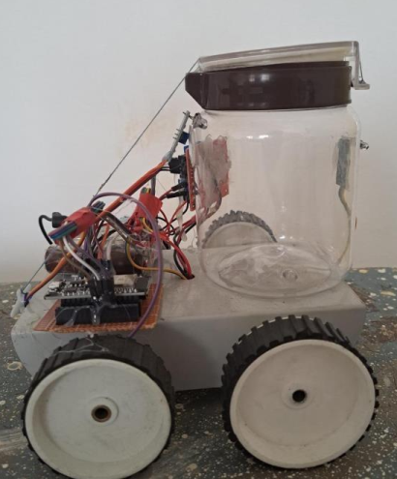and accuracy of the smart waste sorting system, reducing the need for manual labor in waste segregation. In [9], the authors highlighted the importance of effective waste management for sustainable urban development and environmental conservation. It discusses the challenges faced by traditional waste management methods and introduces the concept of the proposed intelligent waste management application. The use of IoT and the Genetic Algorithm–Fuzzy Inference System (GA-FIS) as the underlying technologies for waste optimization is briefly mentioned. The authors discuss the potential implications of the application in real-world waste management scenarios and propose future research directions to further enhance the system's efficiency and effectiveness.

The techniques used in the literature survey leverage various technologies such as sensors, RFID, GPS, machine learning, and big data analytics to optimize waste collection, segregation, and disposal processes. The research works contribute to the development of efficient and sustainable waste management solutions, which are essential for promoting environmental conservation and creating smart cities.

# methodology

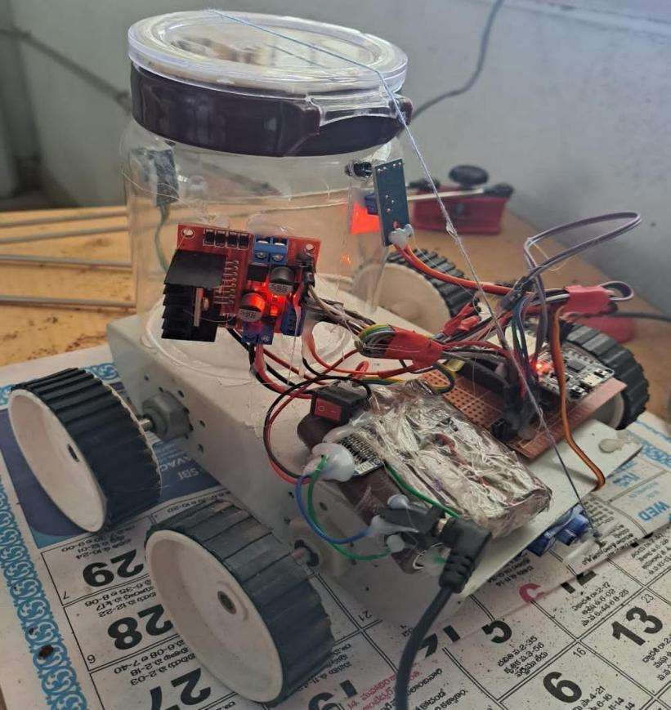The proposed system for a dustbin robot with ESP32 would consist of a few key components. Firstly, the robot itself would be equipped with sensors to detect when it is close to a bin that needs to be emptied.

1. Proposed IOT based garbage monitoring model

The sensors could be ultrasonic or infrared, for example. Once the robot detects a bin that needs to be emptied, it would indicate with LED. To control the robot, an ESP32 microcontroller and adafruit server could be used. This would provide a powerful and versatile platform for controlling the robot's movements and processing sensor data. The ESP32 could also be used to communicate with a remote control or a mobile app, allowing the robot to be controlled and monitored from a distance. Overall, a dustbin robot with ESP32 would be a highly effective and efficient solution for managing waste in a variety of environments, from homes and offices to public spaces and industrial facilities. Figure 1 shows images of proposed IOT based garbage monitoring system.

1. Automated dustbin with intelligent level monitoring

An additional component of the process involves classifying the garbage as either metallic, dry, or liquid, and placing it in one of three distinct containers. When determining the sort of waste present, many types of sensors are used. Continuously monitoring the amount of waste in the bins ensures that the bins will not overflow and that they will be collected on time. The notice together with the location of the bin's placement is sent to the authority that is responsible for this matter. The proposed model for garbage Segregation is shown in figure-3.

# experiments and results

The proposed model is shown in figure-2. Firstly, the infrared sensor determines whether or not the trash container is full of debris. In the event that the container is filled to its maximum capacity, the sensor will recognize this fact and communicate this information to the PIC16F877A microcontroller. It is able to identify whenever there is a human or an item in the vicinity of the trash can and allow the trash can to open the lid in order to dispose of garbage. One of the infrared LEDs has its light source permanently connected to it, while the other infrared LED is connected to the base terminal of the PNP transistor since it is the spectator.

1. Proposed IOT based model for garbage segregation

Resistors with values of 100 and 200 ohms, transistors with values of BC547 and BC557, an LED, and two IR LEDs are the fundamental elements of this sensor circuit. The innovative microcontroller device known as Arduino Uno may be operated with the help of the Arduino Uno. There is no requirement for the establishment of additional apps in addition to Uno. To begin, choose "Devices Arduino Board, Sheets menu" from the available options to begin providing data to the microcontroller located on the board. Because each individual IC on an Arduino Board is an ATmega328 and has a loader similar to the one described, it is possible to transfer new code without the assistance of an external PC software developer. If we want to get started with coding in electronics, the Arduino UNO is the board that you should choose. "If this is your first time interacting with other users on the platform, the UNO is the most powerful board you can begin having fun with." The Arduino family as a whole contains several boards, the most useful of which being the UNO.

The segregation module is shown in figure-3. When the container has reached its capacity, an indicator in the form of flashing LEDs. As soon as the container is full, it can be manually redirected along the path to the dump, and then it will return to its starting place. It is also able to relocate to another location in order to gather the garbage. When a person approaches the trash can, the lid opens, and the trash is collected. Without the aid of a person, it can move from one location to another. It assists in maintaining a clean environment by sounding an alert when the dustbin is full. Separating trash into recyclable, compostable, and nonrecyclable loads is a key step in achieving these goals and putting the "Reuse, Reduce, and Recycle" idea into practice. Wet trash may be broken down into plant food like manure, whereas dry trash and metal trash can be reused as raw materials.

# conclusion

In this work, to preserve and dispose of the garbage already in the bin and to limit the quantity of waste accumulation, several projects have been ongoing. Thus, by using these smart bins everywhere in the globe, the bins will be user-friendly and the area surrounding them would be hygienic. As well as that, important for the authorities who may alert those involved to stop a garbage from overflowing, reducing the need for human monitoring. We can efficiently monitor the entire garbage disposal process with this. The dustbin has an infrared sensor system to look for things put nearby. When we store waste near the trash can, this system will sound an alert. This will decrease the amount of time the trash can be overfilled, which will benefit society, the environment, and our surroundings for the improvement of the future.

##### References

1. Sayali Sonde , Rupesh More , Dipesh Bopche , Monica Gunjal , Gayatri Londhe "Smart Dustbin Using Arduino" Iconic Research And Engineering Journals Volume 5 Issue 11 2022 Page 243-248.
2. A. Tripathi, et al.,”Cloud Based Smart Dustbin System for Metro Station”, International Conference on Internet of Things: Smart Innovation and Usages, 2018.
3. Grewal Kaushal, “RFID Based Security and Access Control System Using Arduino with GSM Module”, IJEEE, Vol-2, Issue-2,2015,

e-ISSN: 1694-2310 | p-ISSN: 1694-2426.

1. Nabaneeta Banerjee et al.,,” Smart Dustbin”, July 2022,IJIRT, vol-9, Iss-2, ISSN: 2349-6002.
2. C. Kolhatkar, B. Joshi, P. Choudhari and D. Bhuva, "Smart E-dustbin," 2018 International Conference on Smart City and Emerging Technology (ICSCET), Mumbai, India, 2018, pp. 1-3, doi: 10.1109/ICSCET.2018.8537245.
3. Divya Shivaji Yadav et al.“ *IOT Based Smart Dustbin*”, July 2021,IJIRT,Vol-8, Iss- 2 ,ISSN: 2349-6002.
4. Sundar Kumar et al., “Smart Dustbin-Garbage Monitoring System by Efficient Arduino Based", International Conference on Intelligent Computing Systems, ICICS 2017, http://dx.doi.org/10.2139/ssrn.3126098.
5. S.Rajput et al., “ Smart Waste Management Using IoT Technologies: A Review", International Journal of Engineering and Advanced Technology (IJEAT), 2019.
6. S. Thaseen Ikram, V. Mohanraj, S. Ramachandran, and A. Balakrishnan, “An Intelligent Waste Management Application Using IoT and a Genetic Algorithm–Fuzzy Inference System,” Applied Sciences, vol. 13, no. 6, p. 3943, Mar. 2023, doi: 10.3390/app13063943.